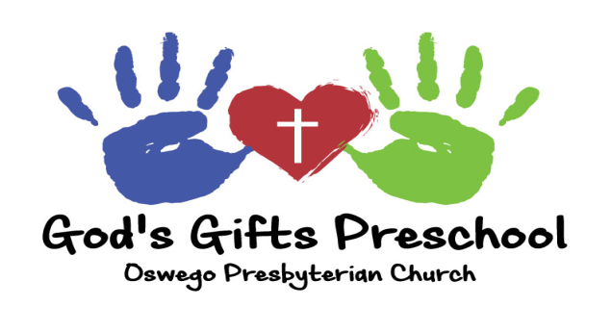
REGISTRATION FORM
2022-2023

Child’s Name:

Child prefers to be called:

Age: Birthday: Month: Day: Year:

Parents/Guardians:

Siblings Name /Ages:

Home Phone: Cell Phone:

Home Address:

Primary Email:

Parent Name:

Parent’s Work #: Cell #:

Workplace and address:

Parent Name:

Parent’s Work #: Cell #:

Workplace and address:

(PLEASE COMPLETE BACK OF REGISTRATION)

Child’s Name:

Any known allergies?

Special needs?

Additional services (i.e. speech)

Friend Relative

Newspaper Drive By

Website Other

Program Offerings for 2022-23 (Number by preference 1-2)

THREE/YOUNG FOURS PRESCHOOL PROGRAM: This preschool program is for children who are three years old or young four year olds and who will NOT be attending Kindergarten next year.

3 Year Old: T/Th 9:15 -11:45 $170.00/month
3 Year Old: M/W/F 9:15 -11:45 $215.00/month

PRE-K PROGRAM: This Pre-K program is for children who will be 4 years old by September 1^{st.}

Pre-K M/W/F 9:15 -11:45 $215.00/month
Pre-K M-TH 9:15 -11:45 $250.00/month
Pre-K M-F 9:15 -11:45 $304.00/month

Pre-K M/W/F 9:15-12:45 $287.00/month
Pre-K M-TH 9:15-12:45 $336.00/month
Pre-K M-F 9:15-12:45 $411.00/month

$70.00 non-refundable registration fee is due at time of enrollment. (Make checks out to God’s Gifts Preschool)

Cash: Check #

**Tuition will be paid in 9 monthly payments beginning Aug. 2022**

